1. INTRODUCTION

1.1 Project Overview:
In India, the Public Distribution System (PDS) plays a vital role in providing essential commodities such as rice, wheat, sugar, and kerosene to citizens through ration cards. Despite its importance, the ration distribution process still relies heavily on manual procedures. Long queues, poor crowd management, lack of transparency, and inefficient service delivery are common problems faced by beneficiaries at ration shops.
The Ration Card Queue Management System is a web-based solution designed to overcome these challenges by introducing a digital platform for queue and token management. The system enables users to generate tokens online, monitor token status, and provide feedback after receiving services. Staff members can manage token flow effectively, while administrators can supervise the entire system through a centralized dashboard.
This project aims to reduce physical crowding, minimize waiting time, ensure fairness in service distribution, and improve transparency. By using modern web technologies such as PHP, MySQL, HTML, CSS, and JavaScript, the system provides a secure, scalable, and efficient solution for ration shops.
The proposed system improves the overall experience for users and authorities by replacing manual processes with automated workflows. It ensures accurate record-keeping, real-time status updates, and better accountability.
Additionally, the system helps government authorities maintain proper digital records that can be used for audits and analysis.The platform also minimizes human errors that commonly occur in manual record maintenance. By reducing physical interaction and overcrowding, the system contributes to improved hygiene and safety at ration shops. Furthermore, the feedback and rating mechanism enables continuous service improvement by identifying issues and service gaps. Overall, the system promotes digital governance and aligns with India’s vision of e-Governance and Digital India initiatives.

1.2 User Module
The User is the primary beneficiary of the system.
Features:
- User Registration
Users register using ration card ID, name, username, and password.
- User Login
Registered users log in securely to access services.
- Token Generation
Users can generate tokens online to avoid physical queues.
- Token Status Tracking
Users can view token status such as Pending, Waiting List, or Completed.
- Feedback & Rating
Users can submit feedback and ratings after service completion.
- Logout
Secure session termination.

1.3 Staff Module
Staff members manage daily ration distribution operations.
Features:
- Staff Login
Authorized staff can log in securely.
- View Tokens
Staff can view tokens assigned for the day.
- Update Token Status
Staff update token status (Pending, Waiting List, Completed).
- Service Monitoring
Ensures smooth and orderly ration distribution.

1.4 Admin Module
The Admin controls and monitors the entire system.
Features:
- Admin Login
- Manage Users
- Add & View Staff
- Monitor Tokens

2.SYSTEM SPECIFICATION

2.1 Hardware Specification
- Processor : Intel Core i3 or above
- RAM : 4 GB or higher
- Hard Disk : 160 GB
- Operating System : Windows 7/8/10

2.2 Software Specification
- Front End : HTML5, CSS3, JavaScript
- Back End : PHP
- Database : MySQL
- Server : XAMPP

2.3 SOFTWARE DESCRIPTION
The Ration Card Queue Management System is developed using modern and reliable web technologies that ensure performance, security, scalability, and ease of maintenance. Each software component plays a vital role in the smooth functioning of the system.

HTML (HyperText Markup Language)
HTML is used to create the basic structure of the web application. It defines the layout of web pages such as login forms, registration pages, dashboards, tables, and feedback forms. HTML ensures that the content is well-structured and accessible through any standard web browser. In this project, HTML forms are used to collect user input such as login credentials, ration card details, token requests, and feedback messages.

CSS (Cascading Style Sheets)
CSS is used to enhance the visual appearance of the application. It controls colors, fonts, layouts, spacing, animations, and responsiveness. Premium UI elements such as dashboards, cards, buttons, tables, side menus, and headers are styled using CSS. Media queries are implemented to make the application responsive across different screen sizes, ensuring usability on desktops, tablets, and mobile devices.

JavaScript
JavaScript is used to add interactivity and client-side validation to the system. It improves user experience by validating forms before submission, showing or hiding elements dynamically (such as add staff forms), refreshing token status, and handling user interactions without reloading the page. JavaScript also enhances responsiveness and ensures faster feedback to users.

PHP (Hypertext Preprocessor)
PHP is the core server-side scripting language used in this project. It handles business logic, session management, authentication, authorization, and communication with the database. PHP processes user requests, validates credentials, generates tokens, updates token status, manages staff details, and securely stores user feedback and ratings. Prepared statements are used in PHP to prevent SQL injection attacks, ensuring application security.

MySQL Database
MySQL is used as the backend database to store and manage all system data. It stores information related to users, staff, tokens, feedback, and ratings. The relational database design ensures data integrity and consistency. Queries are optimized to retrieve data efficiently for dashboards, reports, and search functionality. MySQL enables easy scalability and reliable data storage.

XAMPP Server
XAMPP is used as the local development server environment. It includes Apache server, MySQL database, and PHP interpreter in a single package. XAMPP allows developers to test the application locally before deployment. It simplifies configuration and provides a stable platform for development and testing.

3. SYSTEM ANALYSIS

3.1 Existing System
The existing ration distribution system primarily operates using manual processes. Beneficiaries are required to physically visit ration shops to collect essential commodities. Token distribution, verification, and record maintenance are handled manually by staff, which often leads to inefficiency and errors.
In the current system, beneficiaries must wait in long queues, sometimes for several hours, without any information regarding their turn. There is no proper mechanism to manage or monitor the queue, especially during peak hours or high-demand periods. This results in overcrowding, confusion, and inconvenience for both beneficiaries and ration shop staff.
Records related to ration distribution, beneficiaries, and daily transactions are typically maintained in paper registers. Manual record keeping increases the risk of data loss, duplication, and manipulation. Searching or verifying historical data is time-consuming and unreliable.
The existing system also lacks real-time status tracking. Beneficiaries have no way of knowing whether their token is pending, approved, or completed unless they are physically present at the ration shop. This uncertainty causes repeated visits and unnecessary waiting.
Another major drawback of the existing system is the absence of a feedback mechanism. Beneficiaries cannot formally submit complaints or suggestions regarding service quality. This makes it difficult for higher authorities to monitor performance and improve service delivery.
Additionally, the manual system offers poor transparency and accountability. Since most operations are done manually, monitoring staff performance and preventing malpractice becomes difficult. The system does not support digital reports, analytics, or centralized monitoring.

Limitations of the Existing System
- Manual token handling and record maintenance
- Long waiting times and overcrowding
- No online or real-time status tracking
- Lack of feedback and complaint management
- High chances of human error and data loss
- Poor transparency and accountability
- Time-consuming and inefficient service delivery
Due to these limitations, the existing system fails to meet the needs of a growing population and modern service expectations.

3.2 Proposed System
The proposed Ration Card Queue Management System introduces a digital and automated solution to overcome the drawbacks of the existing manual system. This system is developed as a web-based application that efficiently manages ration distribution through online token generation and real-time status tracking.
In the proposed system, beneficiaries can generate tokens online without physically visiting the ration shop. This helps in reducing unnecessary crowding and allows users to plan their visit based on token status. Users can log in securely and view their token number and service progress.
Ration shop staff are provided with a dedicated login to update token status such as pending, waiting, or completed. This ensures that token progress is updated in real time and visible to beneficiaries. Staff operations become structured and systematic.
The admin module enables higher authorities to monitor the entire system. Admins can manage staff accounts, view reports, analyze feedback, and ensure smooth operation of the ration distribution process. Centralized control improves transparency and accountability.
All data related to users, staff, tokens, and feedback is stored in a centralized database, reducing the risk of data loss and duplication. The system supports secure authentication and role-based access control to protect sensitive information.
The proposed system also includes a feedback and rating mechanism, allowing beneficiaries to submit their opinions regarding service quality. This helps authorities identify issues and improve service efficiency.
By automating the queue management process, the system ensures faster service delivery, better crowd control, and improved user satisfaction. It also supports scalability, making it suitable for deployment across multiple ration shops.

Advantages of the Proposed System
- Reduced crowding at ration shops
- Online token generation and management
- Real-time token status tracking
- Time-saving and user-friendly interface
- Secure login system for users, staff, and admin
- Centralized and reliable data management
- Improved transparency and accountability
- Feedback and rating system for service improvement
- Efficient and organized ration distribution

4. DFD Level 1
DFD Level 1 breaks down the major processes into detailed sub-processes.

4.1 User Authentication Process
- User enters username and password
- System verifies details from User Database
- If valid, access is granted
- If invalid, error message is shown

4.2 Token Generation Process
- User requests a token
- System checks ration ID and availability
- A new token number is generated
- Token details are stored in Token Database
- Token number is displayed to the user

4.3 Queue & Token Status Management
- Staff logs in
- Staff selects a token
- Updates status (Waiting / Processing / Completed)
- System updates Live Queue Table
- Updated status is visible to users and admin

4.4 Feedback Management Process
- User submits feedback
- System stores feedback in Feedback Database
- Admin retrieves and views feedback reports
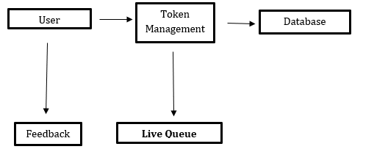
DFD Diagram

ER Diagram :
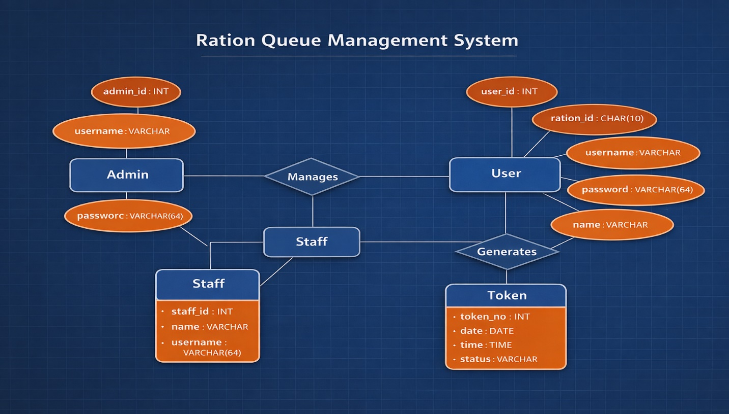

4.3 Database Design
Users Table
Fields | datatype
id (PK) | Int
ration_id | Int
Name | Varchar(255)
Username | Varchar(255)
Password | Varchar(100)

Staff Table
Fields | datatype
id (PK) | Int
Name | Varchar(255)
Username | Varchar(255)
Password | Varchar(255)
created_at | timestamp

Tokens Table
Fields | datatype
token_no (PK) | Int
user_id | Int
Status | Varchar(255)
created_at | timestamp

Feedback Table
Fields | datatype
id (PK) | int
user_name | Varchar(255)
Message | Varchar(255)
Rating | Varchar
created_at | Timestamp

Livequeue Table :
Fields | Type
token_no | int(11)
ration_id | varchar(50)
user_name | varchar(100)
counter_no | int(11)
queue_position | int(11)
Status | varchar(20)
created_at | timestamp
updated_at | timestamp

4.4. INPUT DESIGN
Input design is a critical phase in system development that focuses on the proper collection, validation, and processing of data entered into the system. A well-designed input system ensures that accurate, complete, and consistent data is captured from users, staff, and administrators. In the Ration Queue Management System, input design minimizes errors, improves system efficiency, and enhances user experience by providing simple and secure data entry mechanisms.
The input forms are designed with the following objectives:
- To reduce manual errors during data entry
- To ensure data integrity and security
- To provide user-friendly interfaces
- To validate inputs before processing
- To improve system reliability

User Registration Form
The User Registration Form allows beneficiaries to register into the system using their ration card details. This form collects essential personal and login information required to uniquely identify each user.

Input Fields:
- Ration ID – Unique ration card number
- User Name – Full name of the beneficiary
- Username – Unique login username
- Password – Secure password (encrypted before storage)

Design Features:
- Mandatory field validation to prevent empty submissions
- Unique constraints on ration ID and username
- Password masking for security
- Client-side and server-side validation
- SHA-256 encryption used for password storage

Benefits:
- Prevents duplicate user registrations
- Ensures secure access to the system
- Enables accurate identification of beneficiaries

Staff Login Form
The Staff Login Form is designed for ration shop staff to securely access the system and manage token distribution and live queue updates.

Input Fields:
- Username – Staff login ID
- Password – Encrypted password

Design Features:
- Simple and minimal input fields
- Password masking to protect credentials
- Authentication using database verification
- Session-based access control
- Invalid login attempt handling

Benefits:
- Secure staff authentication
- Prevents unauthorized system access
- Ensures only authorized staff can manage queue operations

Token Generation Form
The Token Generation Form enables registered users to generate a digital token for ration collection. This form is crucial for managing queues efficiently and reducing overcrowding.

Input Fields:
- Ration ID – Automatically fetched from user profile
- User Name – Auto-filled
- Date – Current system date
- Time – Token generation time

Design Features:
- Auto-generated token number
- Prevention of multiple tokens for the same day
- Real-time validation
- Status assignment (Waiting)
- Automatic insertion into token and live queue tables

Benefits:
- Eliminates manual token distribution
- Reduces waiting time
- Enables real-time queue tracking
- Improves transparency in ration distribution

Feedback Form
The Feedback Form allows users to submit their opinions and service experience after ration collection. This form helps administrators improve service quality.

Input Fields:
- User Name – Auto-fetched from session
- Feedback Message – User comments or suggestions

Design Features:
- Text area for detailed feedback
- Input validation to prevent empty submissions
- Secure data storage in feedback table
- Admin-only access to view feedback

Benefits:
- Improves service quality
- Identifies system or staff issues
- Encourages user participation
- Enhances transparency and accountability

4.5 OUTPUT DESIGN
Output design refers to the way information is presented to users after processing the input data. A well-designed output ensures that information is clear, accurate, timely, and easy to understand. In the Ration Queue Management System, output design plays a vital role in keeping users informed about their token status, queue position, and system activities. Outputs are displayed through tables, alerts, dashboards, and reports to enhance usability and transparency.
The primary objectives of output design are:
- To present processed information clearly and accurately
- To support quick decision-making
- To improve user satisfaction
- To ensure transparency in ration distribution
- To provide real-time system updates

Token Number Display
The Token Number Display is one of the most important outputs of the system. When a user successfully generates a token, the system displays the token number immediately.

Features:
- Unique token number assigned automatically
- Displayed along with date and time
- Shown on the user dashboard after token generation
- Confirmation message displayed using alerts

Benefits:
- Users receive instant confirmation
- Eliminates confusion in manual token handling
- Ensures organized queue management
- Reduces disputes at ration shops

Token Status Updates
Token status updates inform users about their current position in the queue. The system updates token status dynamically based on staff actions.

Token Status Types:
- Waiting – Token generated and waiting in queue
- Processing – Token currently being served
- Completed – Ration distribution completed

Display Methods:
- Real-time status shown on user dashboard
- Status updates displayed in staff and admin panels
- Color-coded labels for better understanding

Benefits:
- Improves transparency
- Reduces waiting anxiety
- Allows users to plan their visit efficiently
- Enables staff to manage queues effectively

Dashboard Statistics
The Dashboard provides summarized statistical information to administrators and staff. It presents key system data in a visual and structured format.

Information Displayed:
- Total registered users
- Total staff members
- Tokens generated today
- Tokens completed
- Pending tokens
- Live queue count

Output Format:
- Tables for detailed records
- Cards and counters for quick statistics
- Charts and graphs (optional) for better visualization

Benefits:
- Enables quick monitoring of system performance
- Helps administrators make informed decisions
- Improves operational efficiency
- Provides real-time insights into ration distribution

Feedback Reports
Feedback reports are generated from user feedback submissions. These outputs help administrators analyze service quality and identify areas for improvement.

Report Features:
- User name and feedback message display
- Date-wise feedback listing
- Admin-only access
- Stored permanently for reference

Output Format:
- Tabular format for clarity
- Sorting and filtering options
- Printable reports (optional)

Benefits:
- Enhances accountability
- Improves service quality
- Encourages citizen participation
- Helps identify operational issues

5. SYSTEM TESTING & IMPLEMENTATION
Testing is a critical phase in the software development life cycle that ensures the system functions correctly, securely, and efficiently. The main objective of testing in the Ration Queue Management System is to identify errors, validate system requirements, and ensure reliable performance before deployment. Proper testing improves system quality, user satisfaction, and operational accuracy.

Objectives of Testing
The objectives of testing are:
- To verify that all system modules work as expected
- To detect and correct errors at an early stage
- To ensure data accuracy and security
- To validate functional and non-functional requirements
- To confirm system stability under different conditions

Types of Testing
Various testing techniques were applied to ensure the system’s reliability and correctness.

Unit Testing
Unit testing focuses on testing individual modules or components of the system independently.

Tested Modules:
- Admin login module
- Staff login module
- User registration module
- Token generation module
- Feedback submission module

Results:
- All individual functions performed as expected
- Input validation worked correctly
- Database operations (insert, update, select) executed successfully

Integration Testing
Integration testing verifies the interaction between different modules.

Integrated Components:
- User registration with login
- Token generation with live queue update
- Staff token update with user status display
- Feedback module with admin dashboard

Results:
- Data flowed correctly between modules
- No data inconsistency observed
- System handled module interactions smoothly

System Testing
System testing evaluates the complete system as a whole.

Test Scenarios:
- End-to-end token generation and processing
- Admin managing staff and monitoring queues
- Staff updating token status
- Users tracking token status in real-time

Results:
- All system functions operated correctly
- No system crashes or unexpected behavior
- Performance was stable under normal load

Functional Testing
Functional testing ensures that the system meets all functional requirements.

Key Functionalities Tested:
- Secure login authentication
- Token number generation
- Live queue updates
- Status tracking
- Feedback submission
- Admin dashboard operations

Results:
- All functionalities worked as specified
- User roles and permissions enforced correctly

Validation Testing
Validation testing confirms that the system meets user expectations and real-world requirements.

Validation Criteria:
- Ease of use
- Accuracy of token status
- Responsiveness of dashboards
- Clarity of output displays

Results:
- System met all user requirements
- User interface was simple and intuitive
- Output information was accurate and timely

Security Testing
Security testing ensures that the system protects user data and prevents unauthorized access.

Security Measures Tested:
- Password encryption using hashing
- Session-based authentication
- Role-based access control
- Prevention of SQL injection using prepared statements

Results:
- Unauthorized access was blocked
- User credentials were stored securely
- System showed strong resistance to common attacks

SYSTEM IMPLEMENTATION
System implementation is the phase in which the designed system is developed, installed, configured, and made operational. The Ration Queue Management System was implemented using web-based technologies to ensure accessibility, scalability, and ease of use. This phase involved converting system design into executable software and integrating all modules into a functional application.

System Architecture Implementation
The system follows a three-tier architecture:
- Presentation Layer – User interface developed using HTML, CSS, and JavaScript
- Application Layer – Business logic implemented using PHP
- Data Layer – MySQL database for data storage and retrieval
This architecture ensures separation of concerns, improved security, and easier maintenance.

Module Implementation

Admin Module
The admin module provides full control over the system. Admins can:
- Log in securely using encrypted credentials
- Add and manage staff accounts
- Monitor live queues and token status
- View feedback reports
- Maintain overall system operations

Staff Module
The staff module enables staff members to:
- Log in securely
- View live token queues
- Update token status (Pending, Processing, Completed)
- Manage ration distribution workflow

User Module
The user module allows beneficiaries to:
- Register and log in
- Generate digital tokens
- View live queue status
- Track token progress in real-time
- Submit feedback after service completion

Token Management Module
This module handles:
- Token number generation
- Live queue updates
- Status tracking
- Date and time recording
- Linking ration ID with token data
Prepared statements were used to ensure secure database transactions.

Feedback Module
The feedback module enables users to:
- Submit feedback messages
- Rate service quality (optional extension)
- Store feedback securely in the database
- Allow admins to review feedback reports

8.4 Database Implementation
The database was implemented using MySQL and structured into multiple normalized tables such as:
- Admin
- Staff
- Users
- Tokens
- Live Queue
- Feedback
Indexes and constraints were applied to ensure data integrity and fast access.

Security Implementation
Security measures implemented include:
- Password hashing using SHA-256
- Session-based authentication
- Role-based access control
- SQL injection prevention using prepared statements
- Input validation at both client and server sides

Deployment Process
The system was deployed locally using XAMPP:
- Project files placed in the htdocs directory
- Database imported using phpMyAdmin
- Apache and MySQL services started
- Application accessed through a web browser

6.SCOPE OF FUTURE ENHANCEMENTS
The Ration Queue Management System has been designed to provide an efficient and transparent solution for managing ration distribution queues. While the current system meets all functional requirements, there is significant scope for future enhancements to improve performance, scalability, security, and user experience. These enhancements can be implemented as technology advances and user needs evolve.

Mobile Application Integration
A dedicated Android and iOS mobile application can be developed to allow users and staff to access the system more conveniently. Mobile notifications can alert users about token status updates, estimated waiting time, and service completion.

SMS and Email Notification System
Integration with SMS and email services can notify users when:
- Their token is generated
- Their turn is approaching
- Service is completed
This will reduce unnecessary waiting at ration shops and improve user satisfaction.

Aadhaar and Government Database Integration
The system can be linked with government databases such as Aadhaar or PDS databases to automatically verify beneficiary details, reduce duplicate records, and improve transparency.

Advanced Analytics and Reporting
Future versions can include:
- Daily and monthly distribution reports
- Staff performance analytics
- Peak-hour queue analysis
- Predictive analysis for resource planning
This data can help authorities make informed decisions.

Multi-language Support
To improve accessibility, the system can support multiple regional languages such as Tamil, Hindi, Telugu, and Malayalam, ensuring ease of use for beneficiaries across different regions.

Cloud Deployment
Deploying the system on cloud platforms such as AWS or Azure will:
- Improve system availability
- Enable real-time synchronization across locations
- Support large-scale deployment

Enhanced Security Features
Future security enhancements may include:
- Two-factor authentication (2FA)
- Role-based permission levels
- Audit logs for all activities
- Encrypted data storage
.

Integration with Payment Systems
If paid services are introduced, the system can be integrated with digital payment gateways such as UPI or net banking for seamless transactions.

7. CONCLUSION
The Ration Queue Management System was developed to address the challenges faced in traditional ration distribution methods, such as long queues, manual token handling, lack of transparency, and inefficient service delivery. By introducing a digital and automated queue management solution, the system significantly improves the overall ration distribution process.
The proposed system provides a centralized platform where users can generate tokens online, track their service status, and submit feedback. Staff members can manage token flow efficiently, while administrators have complete control over system operations, user management, and performance monitoring. This structured role-based access ensures security, accountability, and smooth coordination between all stakeholders.
The system successfully reduces crowding at ration shops by organizing service queues digitally and providing real-time status updates. The use of a secure login mechanism, centralized database management, and automated record keeping enhances transparency and minimizes errors caused by manual processes. Additionally, the feedback module allows authorities to evaluate service quality and identify areas for improvement.
From a technical perspective, the system demonstrates effective use of web technologies such as HTML, CSS, PHP, and MySQL. The modular design ensures easy maintenance and future scalability. The system has been tested thoroughly and meets all functional requirements defined during the analysis phase.
In conclusion, the Ration Queue Management System is a reliable, efficient, and user-friendly solution that modernizes ration distribution services. It not only improves operational efficiency but also enhances user satisfaction and trust.

APPENDIX
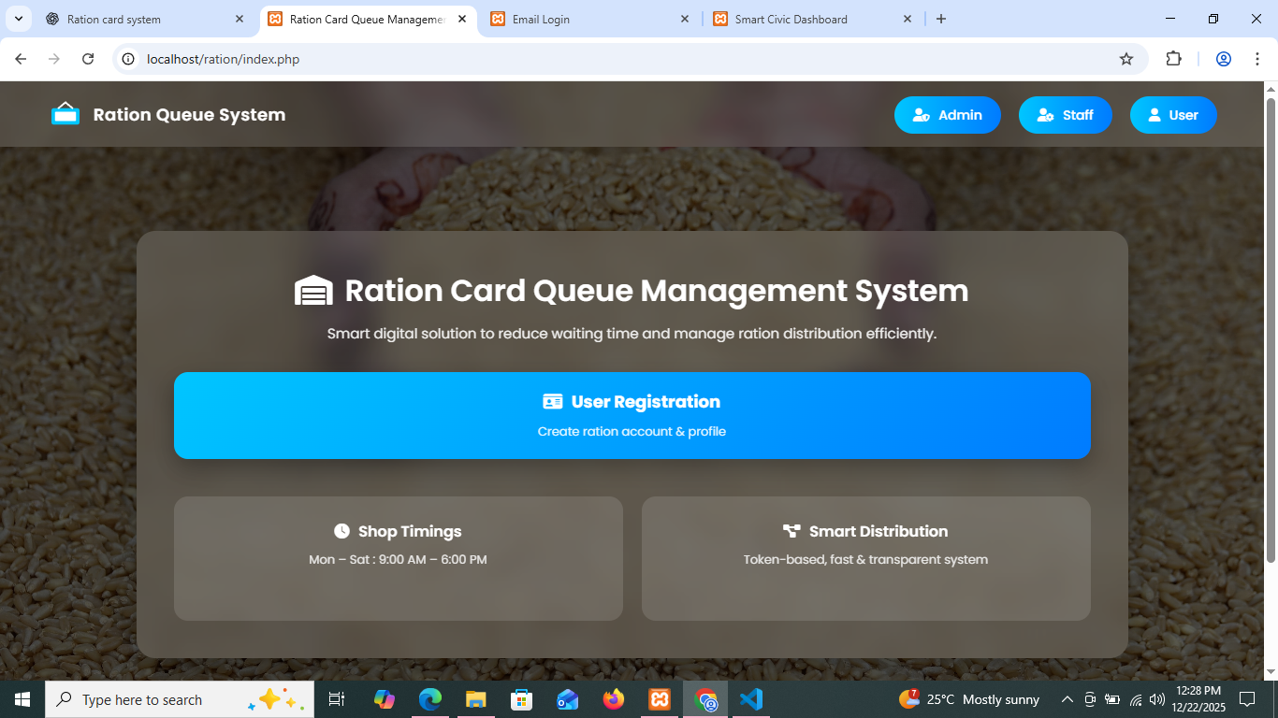
Index Page:

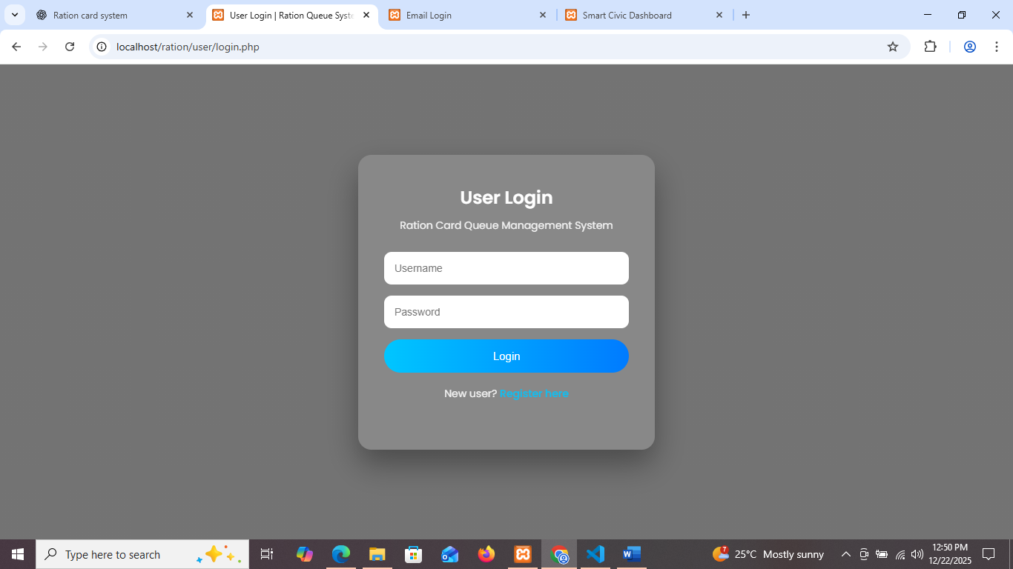
User Login Page :
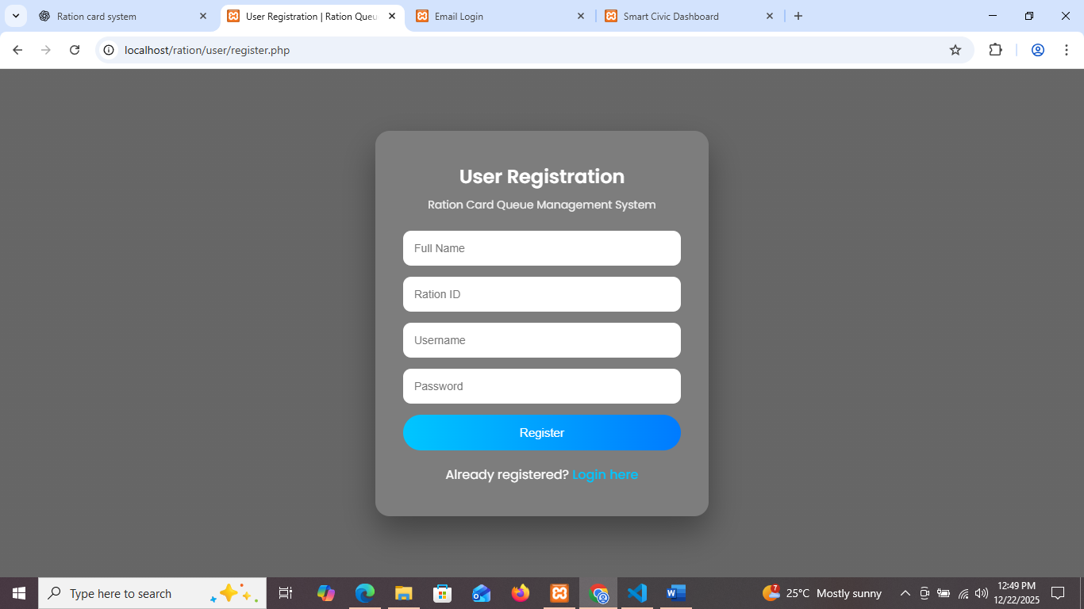
User Register Page:

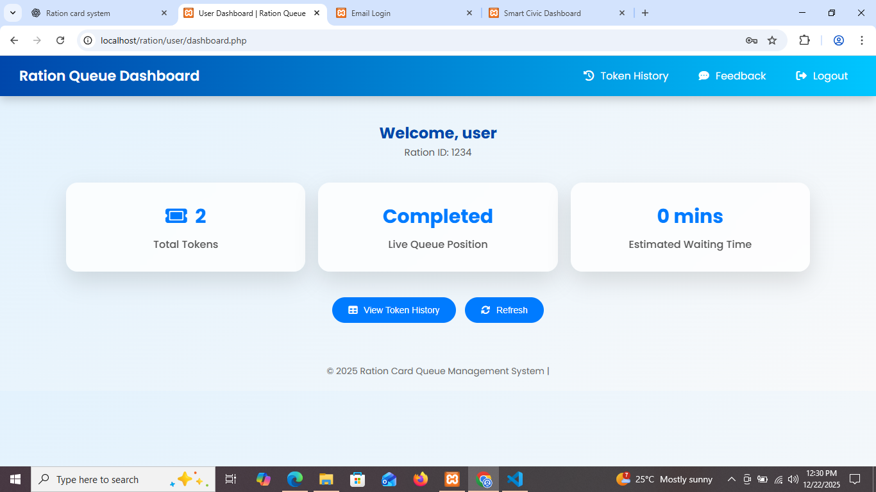
User Dashboard
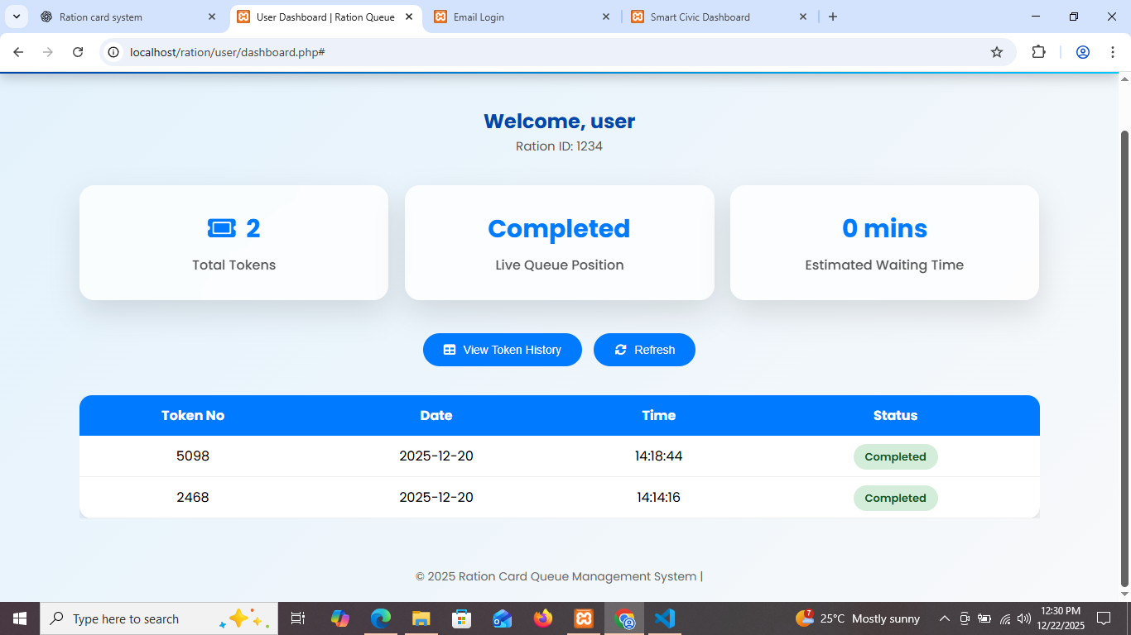
User Dashboard View Token History :

User Give Feedback
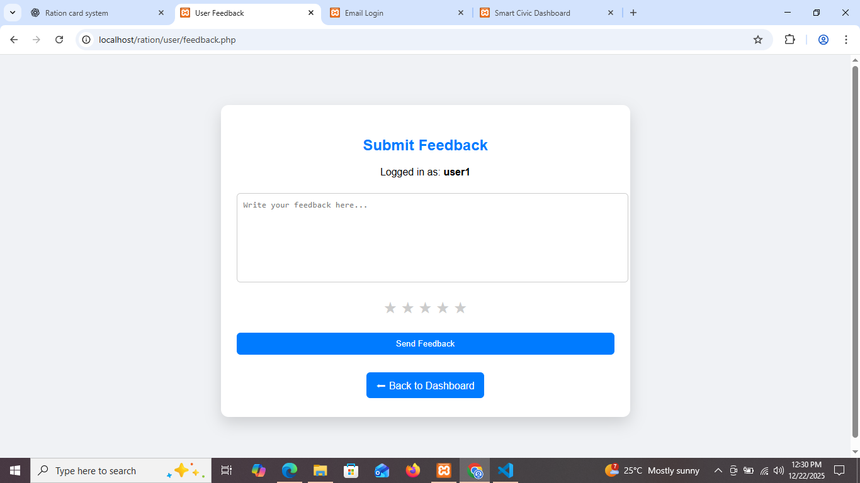
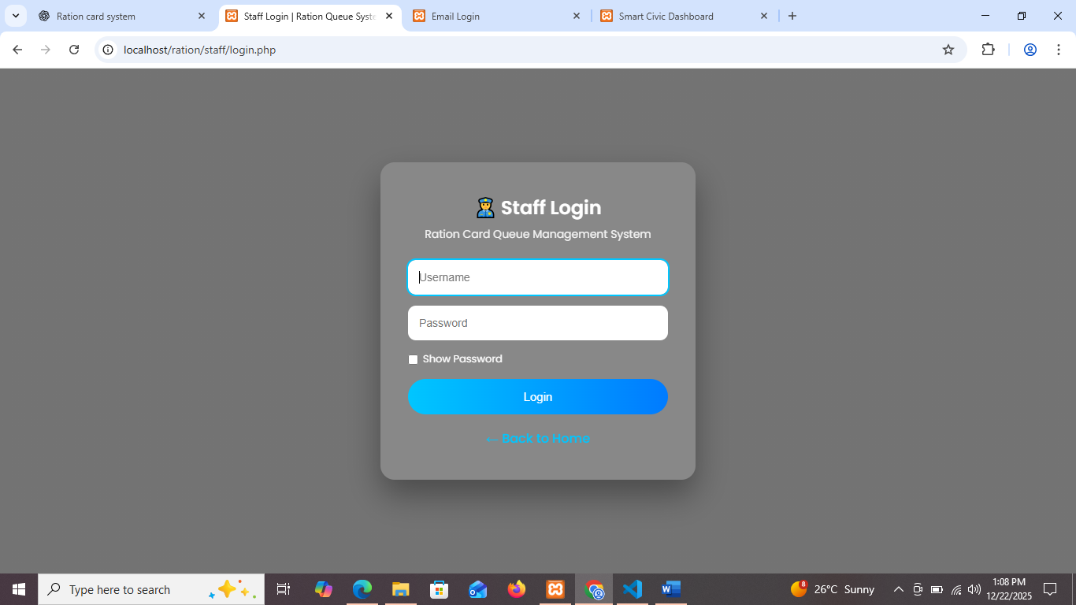
Staff Login :

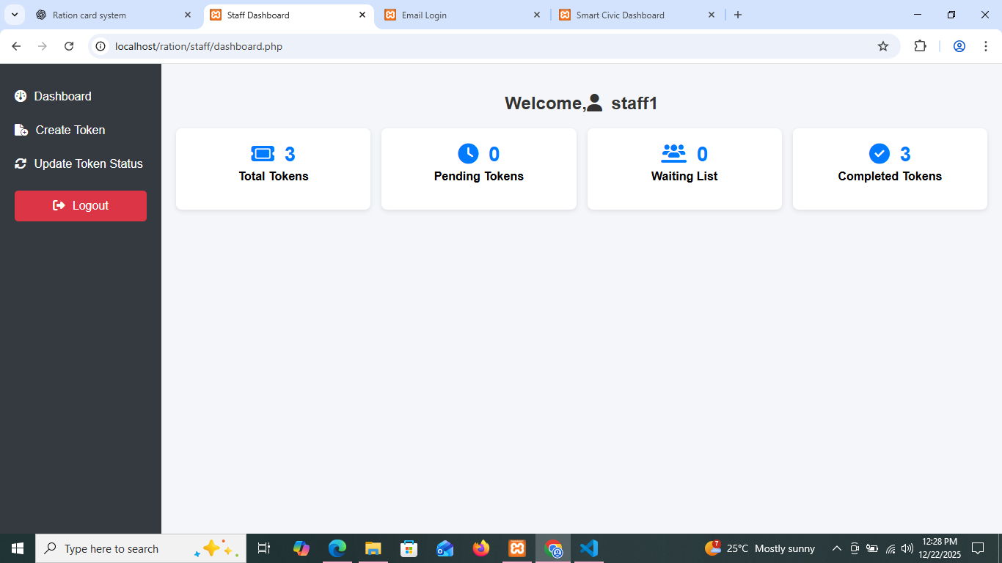
Staff Dashboard :

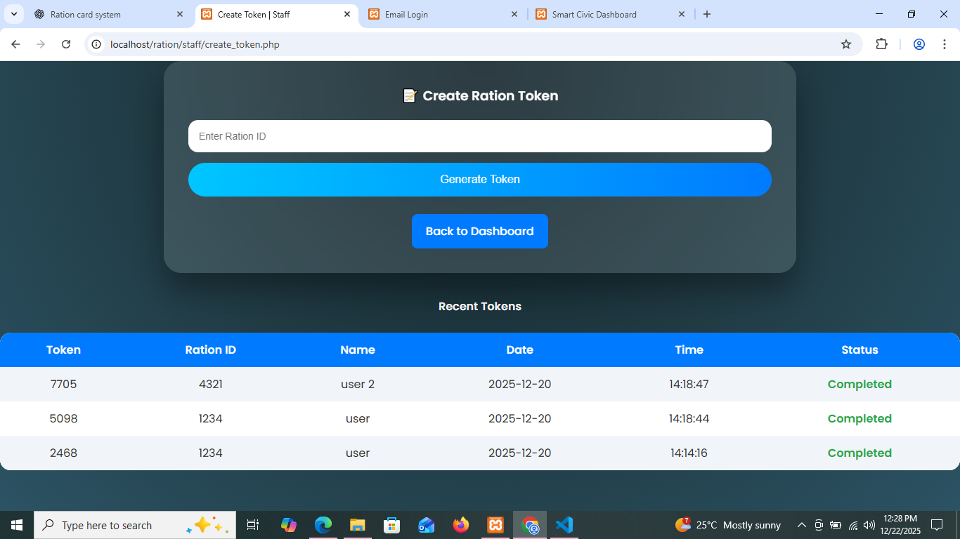
Create Token :

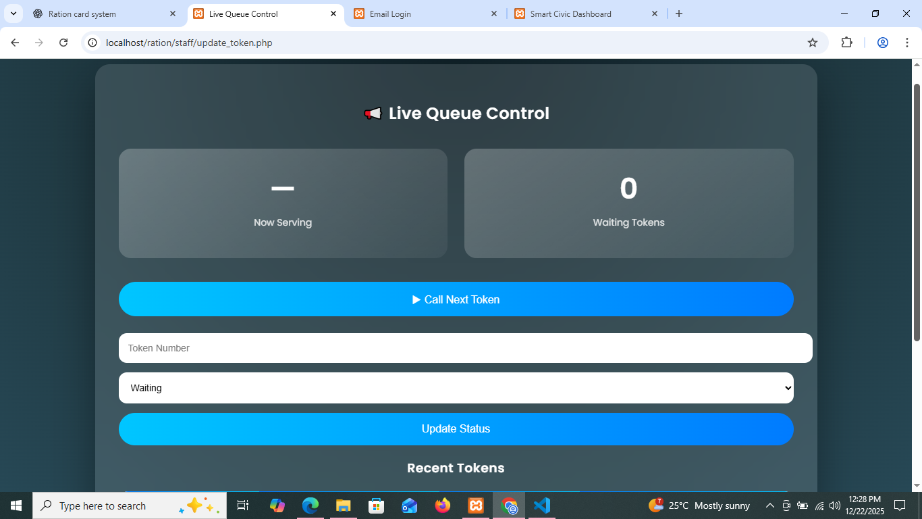
Update Token Status:

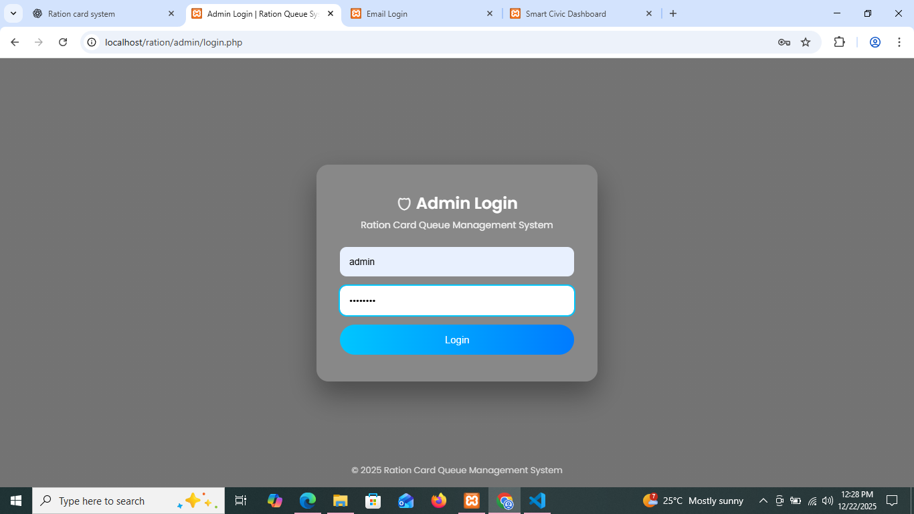
Admin Login:

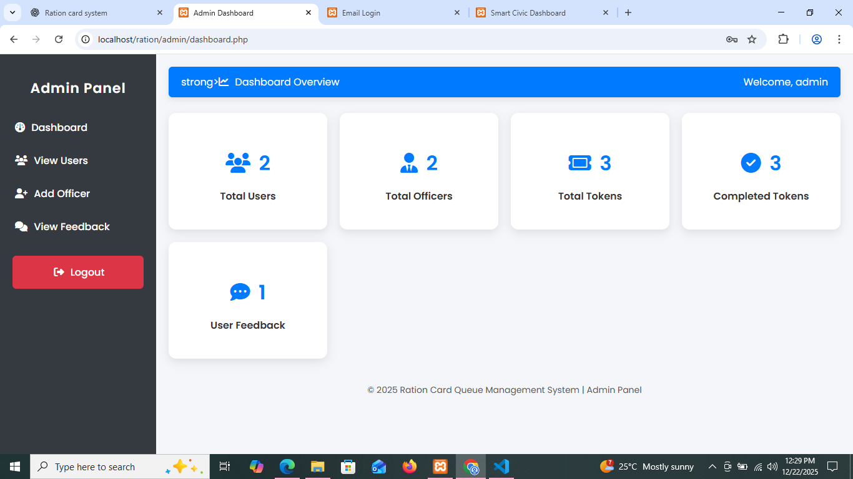
Admin Dashboard:

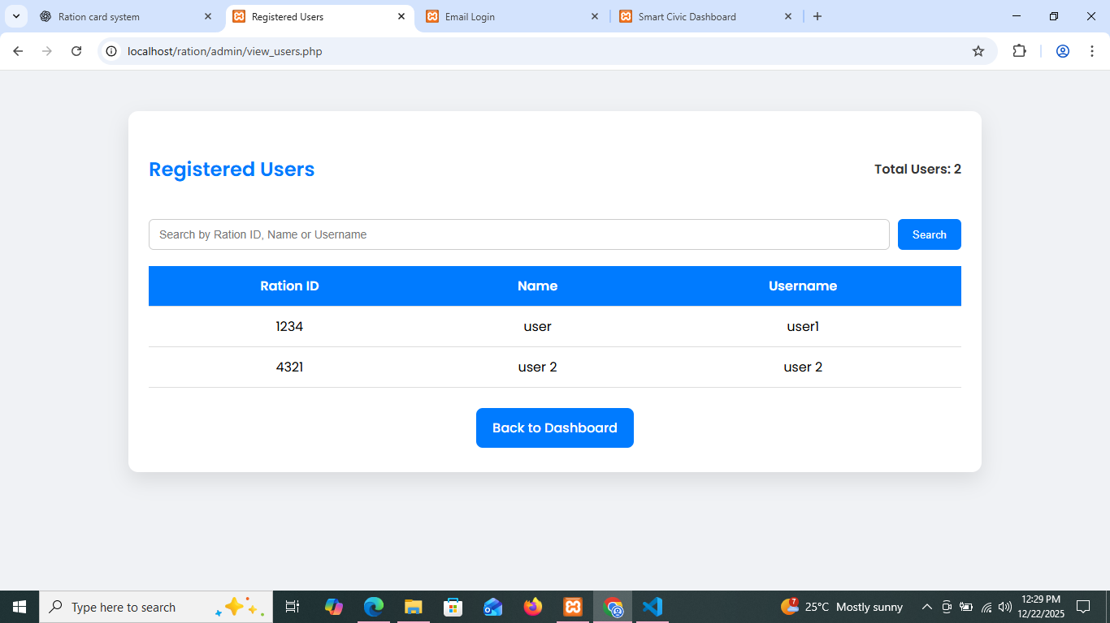
View User :

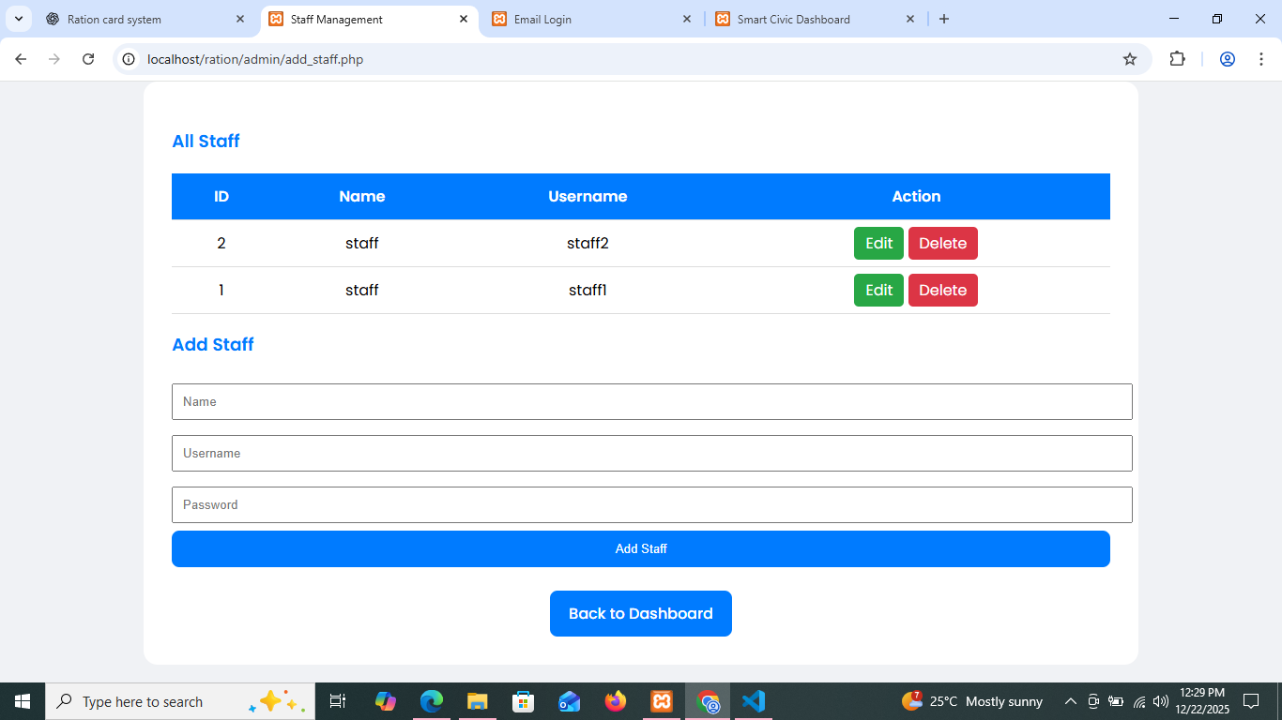
Add Staff :

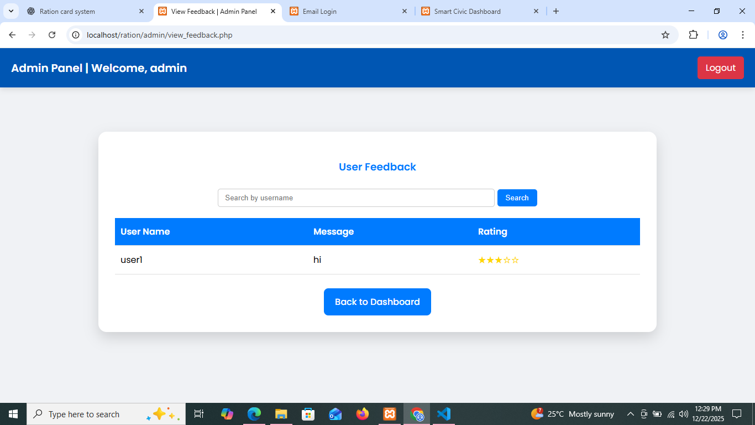
Admin View Feedback:

